**Salesforce Deployment Guide**

Installing and configuring the adapter in Salesforce

***Submitted by***

**Eureka Digitization and Automation Services**

**Document Control**

|  |  |  |
| --- | --- | --- |
| Sr. No. | Type of Information | Document Data |
|  | Document Title | Salesforce Deployment Guide |
|  | Document Code | EDAS_SDG_V1.0 |
|  | Date of Release | 16th August 2021 |
|  | Next Review On | 1st Mar 2022 |
|  | Document Approver | Wilson Nadar |
|  | Document Owner | Kaustubh K. Domale |
|  | Document Author(s) | Kaustubh K. Domale |
|  | Document Classification | Internal |

**Document Reviewer**

|  |  |  |  |
| --- | --- | --- | --- |
| Sr. No. | Document Reviewer | Reviewer Designation | Reviewers E-mail ID |
| 1 | Jaswinder Singh | CTO | [Jaswinder.singh@edas.tech](mailto:Jaswinder.singh@edas.tech) |

**Document Change History**

|  |  |  |  |
| --- | --- | --- | --- |
| **Version** | **Revision Date** | **Nature of Change** | **Date of Approval** |
| 1.0 | 16th Aug 2021 | Initial release | 16th Aug 2021 |

Table of Contents

1. Installing the adapter in salesforce 4

1.1 Prerequisites 4

1.2 Start 4

2. Configuring the adapter in Salesforce 6

2.1 Start 6

3. Configuring screen pops in Salesforce 10

Installing the adapter in salesforce

Complete the procedures below to install and configure the Open CTI VAANI Adapter for Salesforce in your Salesforce environment.

## Prerequisites

* You have installed and configured Web Services.
* You have set up SSL for web server. For more information, see Configure SSL.

## Start

1. Open the following URL to install the latest Open CTI Adapter for Salesforce package in Salesforce:

<https://login.salesforce.com/packaging/installPackage.apexp?p0=04t41000000bSXh>

If you're not logged in, Salesforce prompts for your username and password.

1. Now you should see the **Install Open CTI Adapter for Salesforce** page. Select an installation type. Generally, you should select **Grant access to all users**, but if you want to limit access to the adapter to specific profiles, then you can choose **Install for Specific Profiles** Click **Install**.

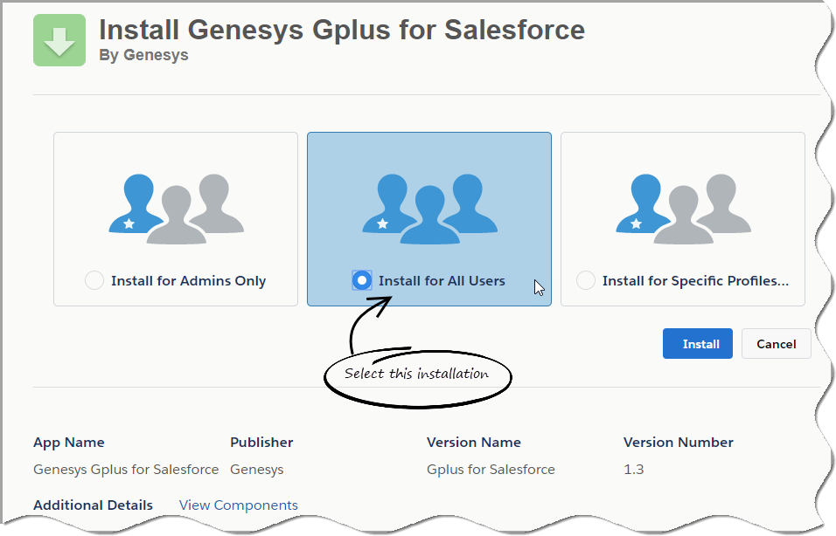

1. When you see the "Installation Complete!" message, click **Done**.

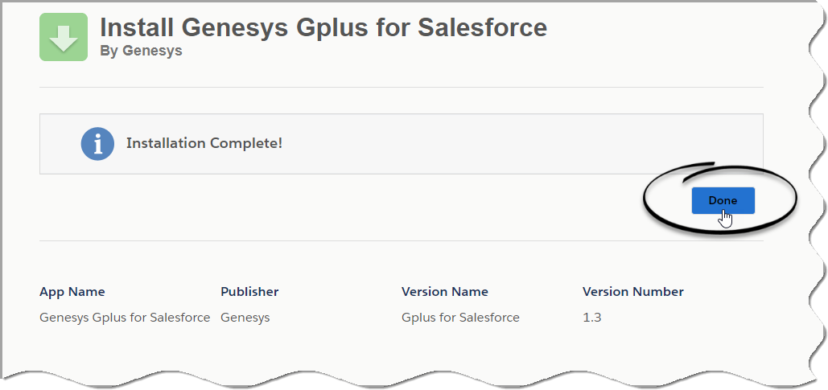

You should be redirected to the **Installed Packages** page, with "Genesys Gplus for Salesforce" included in the list.

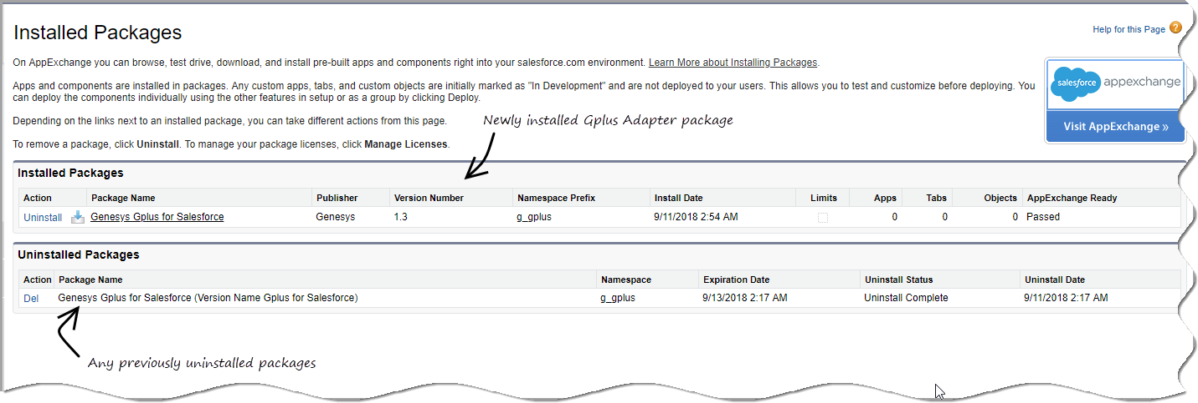

**END**

# Configuring the adapter in Salesforce

Complete this procedure to define your call centre in Salesforce. The call centre was created when you installed the Gplus Adapter for Salesforce package.

## Start

1. If you haven't already, login to Salesforce and go to Setup > Build > Customize > Call Center > Call Centers. Or, you can search for "Call Centers" in the Search All Setup field and select the "Call Centers" result. You should see the Introducing Salesforce CRM Call Center page. Note: You must have administrator privileges.
2. You can select Don't show me this page again if you want to hide the page in the future, and click

Continue.

1. On the All Call Centers page, click Edit next to the Genesys Gplus for Salesforce entry.
2. In the CTI Adapter URL field, replace GWS_HOST:GWS_PORT with the correct host and port for your installation of [Web Services](https://docs.genesys.com/Documentation/IW/8.5.2/Dep/InstallingAndDeploying).

For example: https://198.51.100.23:8090/ui/crm-adapter/ index.html?crm=salesforce

If you're enabling single sign-on in the adapter, add the authType=saml parameter to the CTI Adapter URL.

For example: https://198.51.100.23:8090/ui/crm-adapter/ index.html?crm=salesforce&authType=saml

You should leave the other options at their default values so the adapter works correctly in Salesforce.

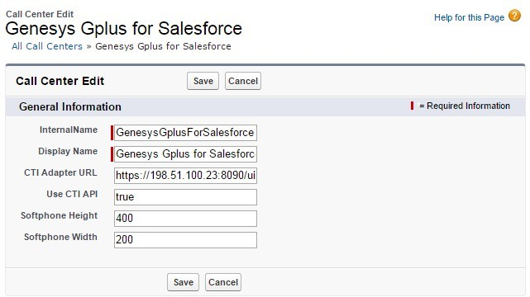

1. Click **Save**.
2. Click **Manage Call Centre Users** and then click **Add users**.

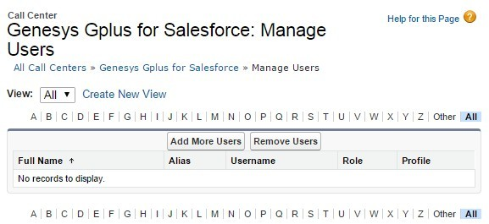

1. On the **Search for New Users** page, you can enter search criteria to find users. Select the ones you want to be able to use the adapter and click **Add to Call Centre**.

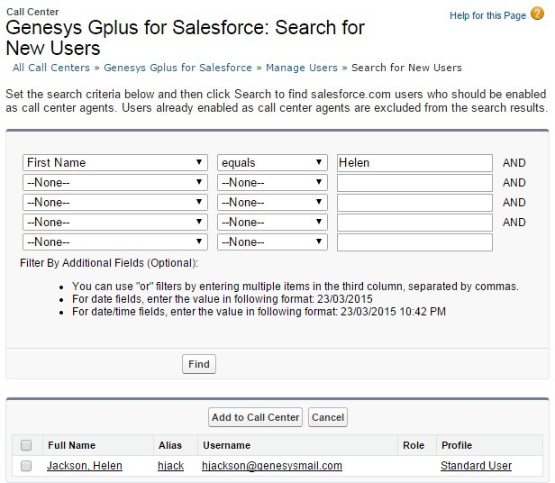

Your selected users are added to the list. You can remove a user on this page at any time.

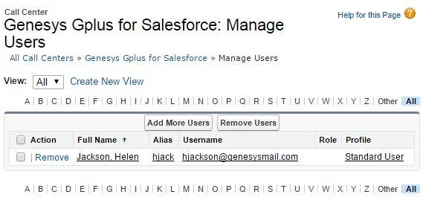

1. To access the adapter in Salesforce Classic, look for it in the left pane of your browser; in Salesforce Console, click the **Phone** button in the bottom right corner.

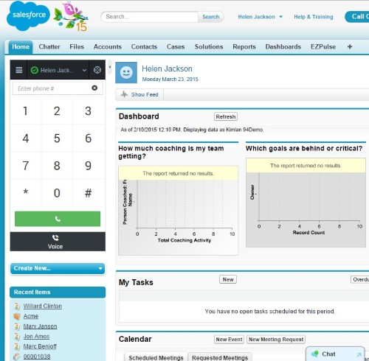

The adapter in Salesforce Classic.

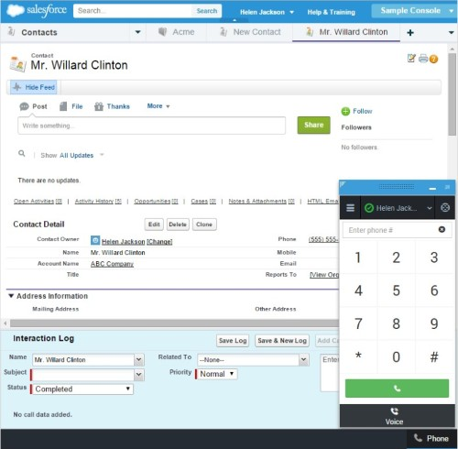

The adapter in Salesforce Console.

**END**

# Configuring screen pops in Salesforce

When an agent receives an external call, the adapter can initiate a screen pop that causes Salesforce to show an appropriate record for the caller. To set up this functionality in Salesforce, login and go to Setup > Customize > Call Center > SoftPhone Layouts to create a SoftPhone Layout. Check out the Salesforce documentation for details about configuration.

In general, there are a couple of things to consider when you set up a SoftPhone Layout for the adapter:

* The Gplus Adapter for Salesforce ignores the SoftPhone Layout settings that control call-related fields. Instead, the adapter gets this information from [Toast and case data](https://docs.genesys.com/Documentation/HTCC/latest/IWWDep/GPAA#Toast_and_case_data) you configure in the Genesys environment.
* Make sure you configure the Screen Pop Settings in the "CTI 2.0 or Higher Settings" section. These settings control whether the screen pop opens in a new window, tab, or Visualforce page.

See Screen pop for more information about configuring screen pops in your Genesys environment.